1. **Create a schema based on the given dataset**

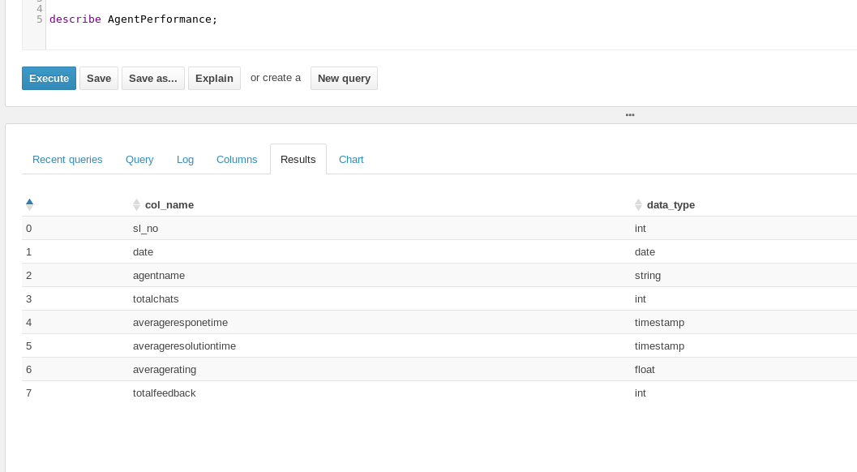

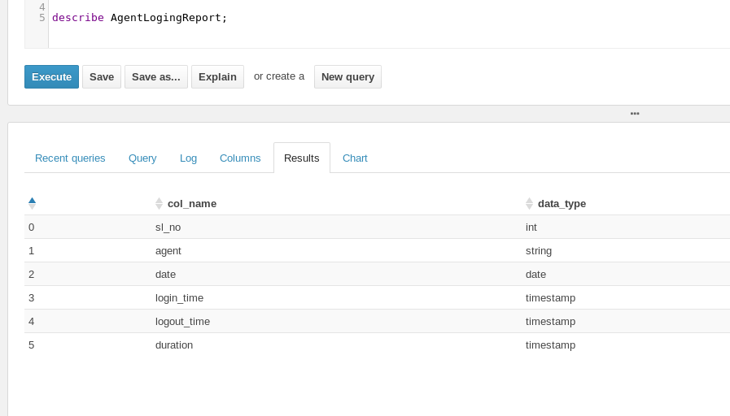

**2. Dump the data inside the hdfs in the given schema location.**





**3. List of all agents' names.**

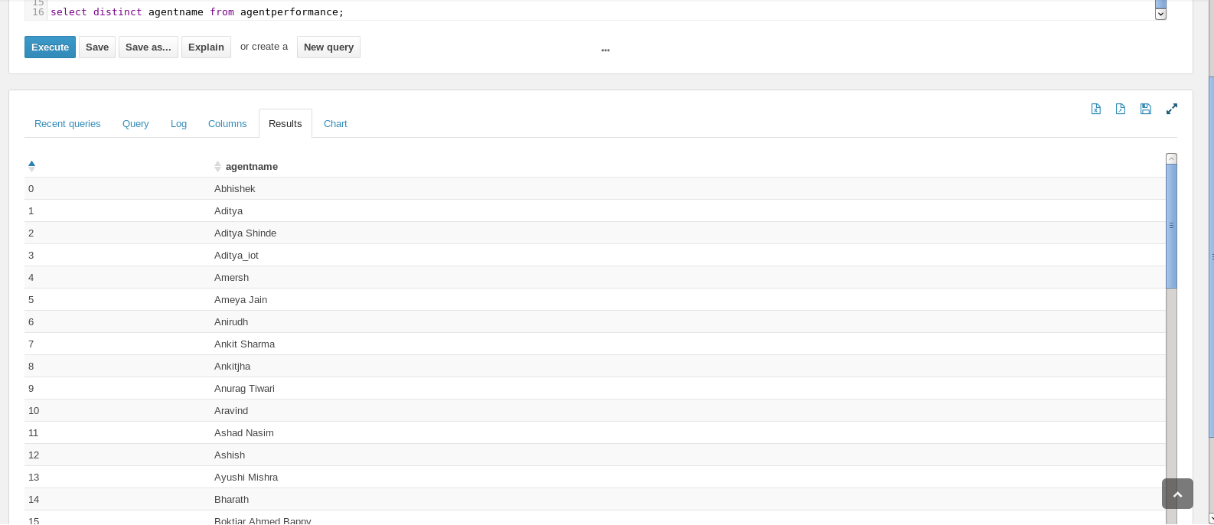

**4. Find out agent average rating.**

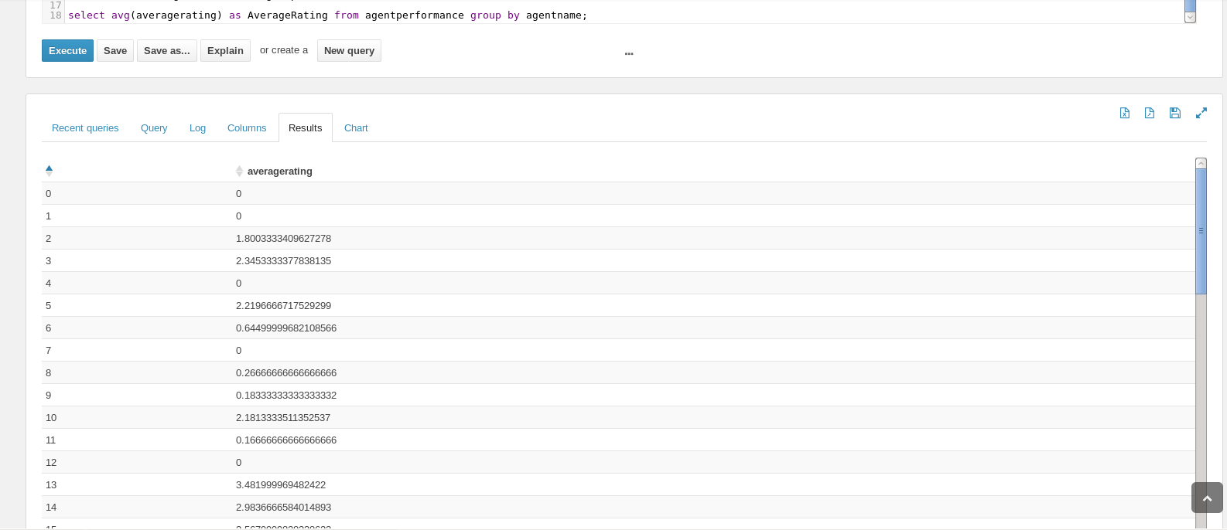

**5. Total Feedback that each agent have received**

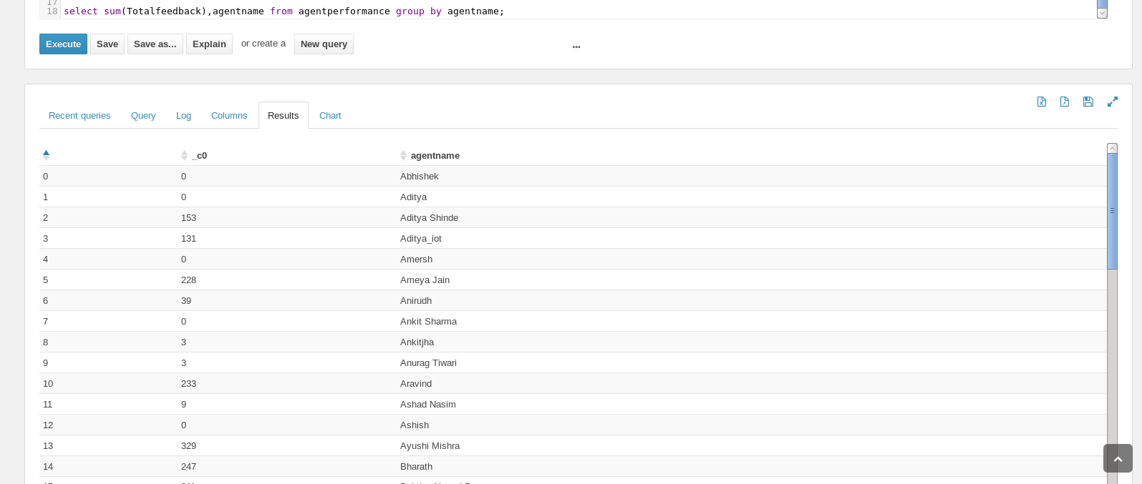

**6. Agent name who have average rating between 3.5 to 4**

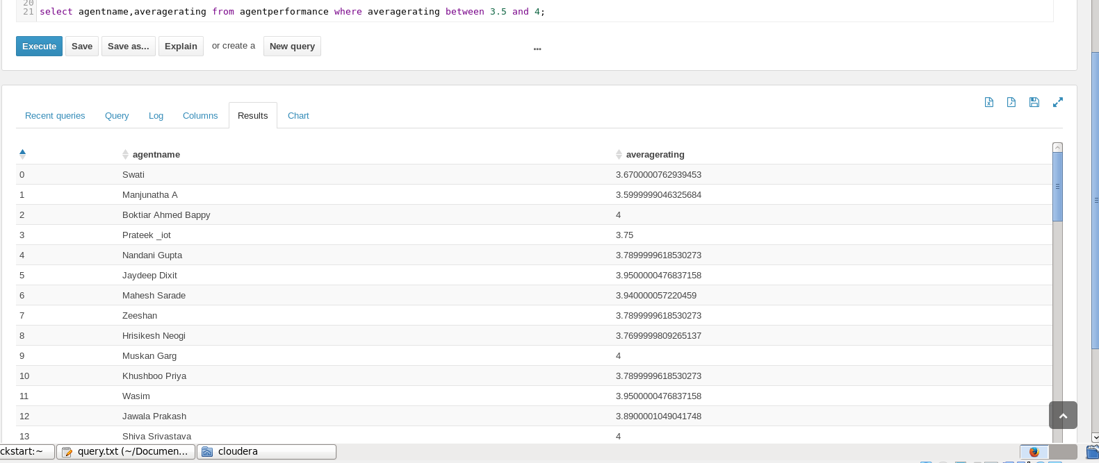

**7. Agent name who have rating less than 3.5**

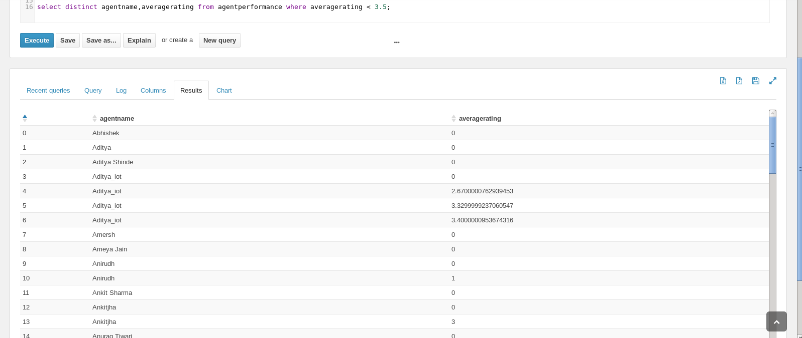

**8. Agent name who have rating more than 4.5**

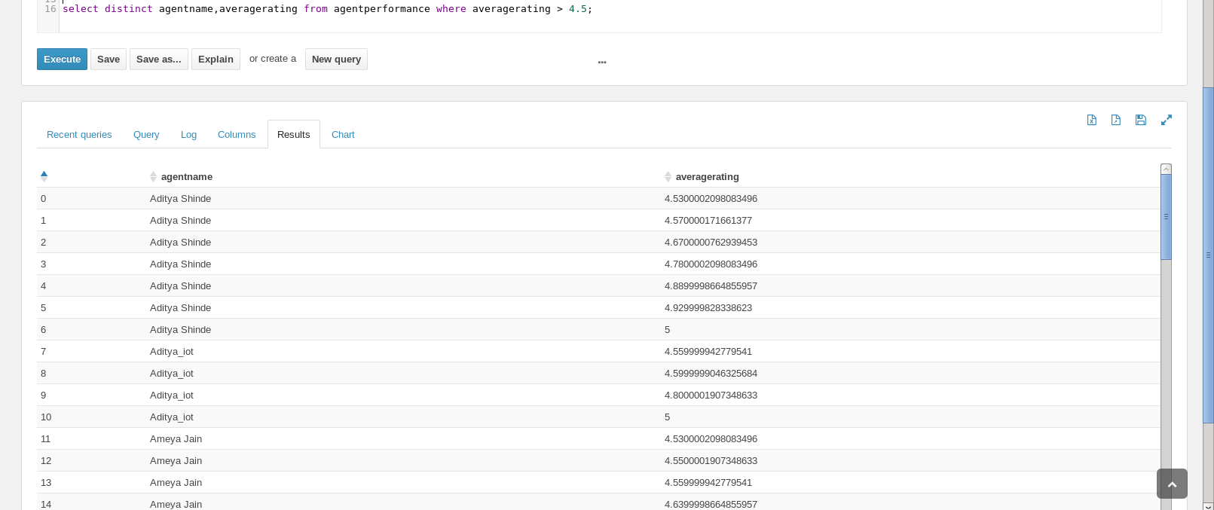

**9. How many feedback agents have received more than 4.5 average**

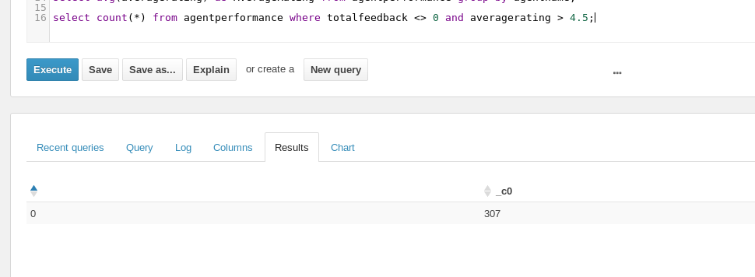

**10. Find the number of chat on which they have received a feedback**

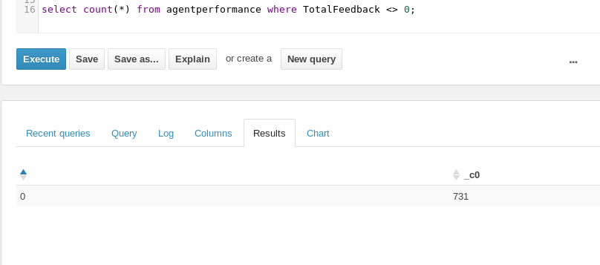

**11. Perform inner join, left join and right join based on the agent column and after joining the table export that data into your local system.**

Reduce-Side Join

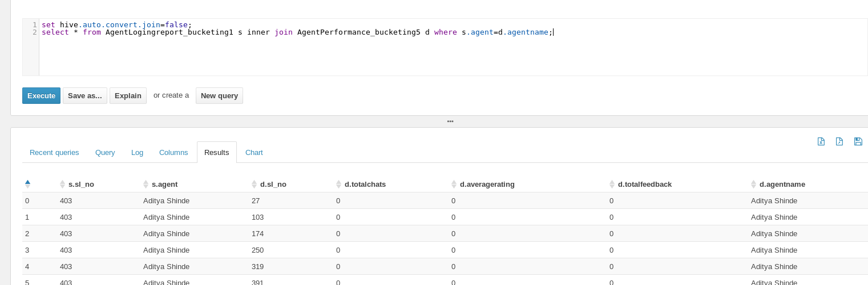

Map Side Join

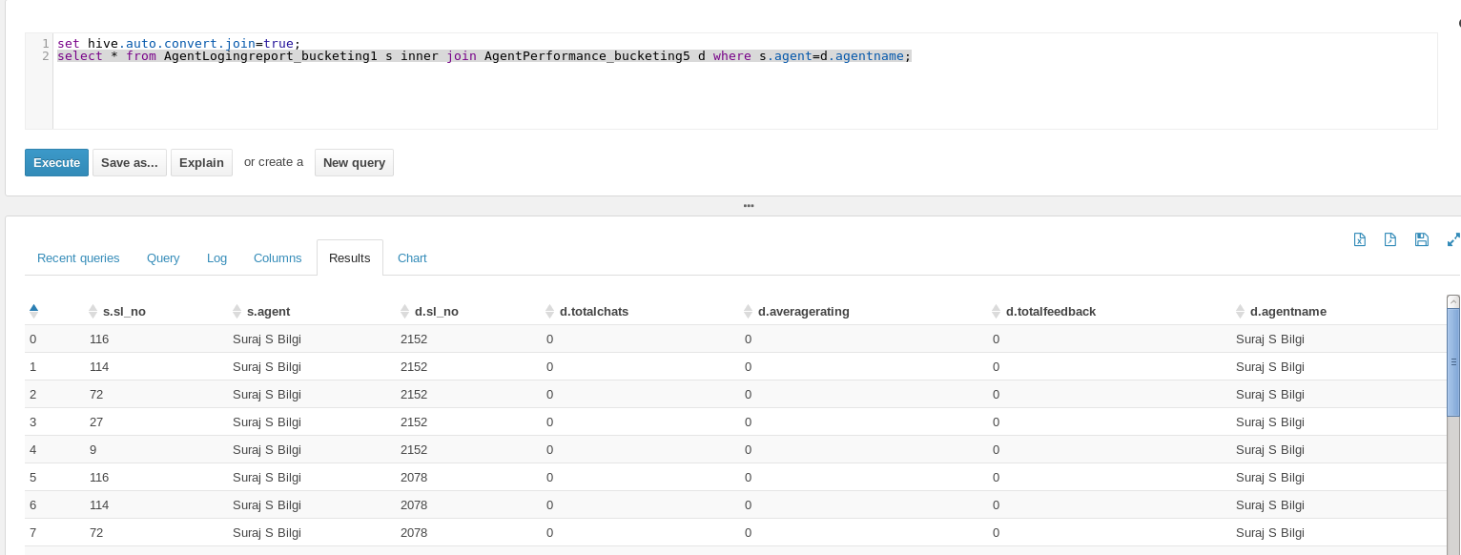

Bucket Map Join

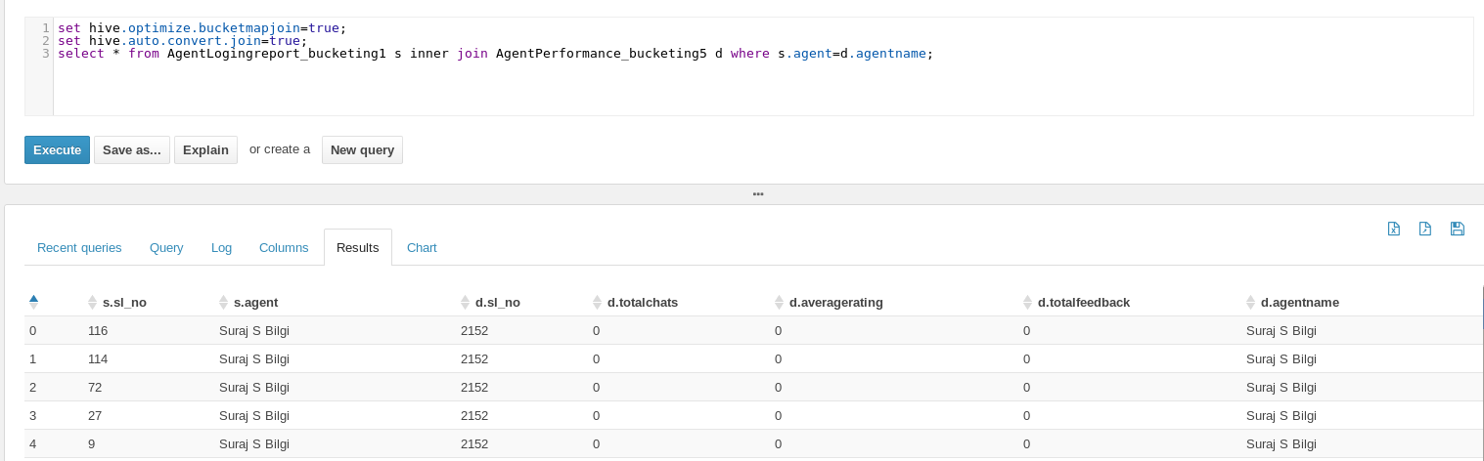

Sorted Merge Bucket Map Join

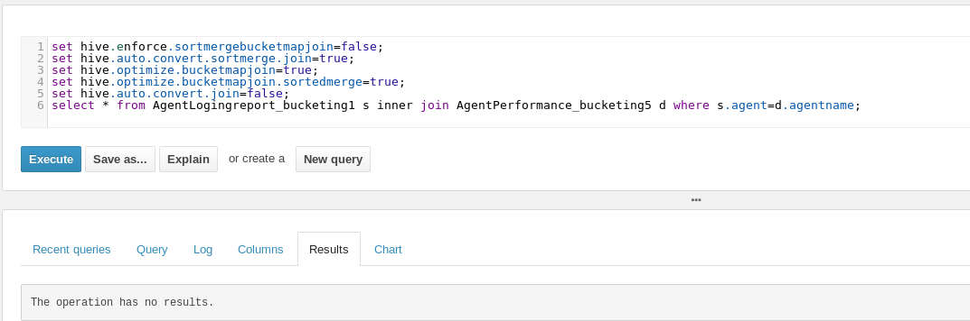

**12. Perform partitioning on top of the agent column and then on top of that perform bucketing for each partitioning.**

